**CHIT CHAT WEB APP**

***Project Report Submitted in partial fulfillment***

***for the award of degree of***

**BACHELOR OF TECHNOLOGY**

***Submitted by*:**

**Nishant Pandey 1713101291**

**Tripuresh Tripathi 1713101195**

**Hansi Saxena 1713101834**

**IN**

**COMPUTER SCIENCE & ENGINEERING**

**SCHOOL OF COMPUTER SCIENCE AND ENGINEERING**

**Under the supervision of**

**Dr. Raju Ranjan**

**Associate Professor**



**May 2021**



**SCHOOL OF COMPUTING AND SCIENCE AND ENGINEERING**

**BONAFIDE CERTIFICATE**

Certified that this project report **“CHIT CHAT WEB APP”** is the bonafide work of “**Nishant Pandey (1713101291), Tripuresh Tripathi (1713101195) and Hansi Saxena (1713101834)**” who carried out the project work under my supervision.

**SIGNATURE OF DEAN SIGNATURE OF SUPERVISOR**

**ACKNOWLEDGEMENT**

I would like to like to express my gratitude to my project guide Dr. Raju Ranjan for guiding me throughout the project. I also feel thankful towards the university for taking me into the graduate program and allowing me to take on this project. I would also like to thank all the professors who helped me during my four-year journey in B-Tech program.

Finally, I would like to thank all my group member for there valuable effort in completing this project.

**TABLE OF CONTENT**

|  |  |  |
| --- | --- | --- |
| **S.NO** | **Particulars** | **Page. No** |
| 1 | Abstract |  |
| 2 | Introduction | 1 |
| 3 | Requirements | 1 |
| 4 | Problem formulation | 1 |
| 5 | Feasibility study | 2 |
| 6 | Scope | 2 |
| 7 | Comparative study | 2 |
| 8 | Merits of proposed system | 2 |
| 9 | Activity time schedule | 3 |
| 10 | Architecture design for proposed method | 4 |
| 11 | Implementation and description of project modules | 6 |
| 12 | Future Scope | 8 |
| 13 | References | 8 |

**ABSTRACT**

This project aims to build a Web app that can be used for communication over the Internet. As we all know wireless communication is must thing nowadays. Secure and reliable communication network is very important. The communication should provide one with security as well as privacy. No one else should be able to listen to conversation happening between two people. This same concept will be used to build this project. We will be building a Web app where people can make room that can be joined by any person, they like to have a conversation with by simply providing them with the credentials of that room. No data of the conversation is saved and will all be deleted as soon as the room is closed. There would be no tracking of data of anyone individual.

**INRODUCTION**

This is a final year project and it is aimed to build a web application that people can use to communicate with each other. This is a socket programming problem and the idea is to not allow user data tracking. The project is not focused on providing a lot of functionality but to provide a simple, easy and fast way to connect to your friends and family without any login procedure. The interface of the project will be as simple as possible so that everyone can easily understand and use the web application. The idea of this project comes from observing different companies that provide similar services. They tract user data and use them to their advantages, due to this they have many lawsuits against them. This project will help people to communicate privately without any backdoor in the system by which data can be tracked. This web application will run on browser hence it can be run on any device weather phone, tablet or pc and on any operating system. The team will work hard to deliver all the promised features on release or in future updates.

**REQUIREMENTS**

There are some requirements for this project. they are as follows:

Required tools:

* HTML
* CSS
* JavaScript
* React JS
* Socket
* Node JS

Required software

* Windows 10
* Visual studio code
* Framework and Libraries of JavaScript like react, socket and node
* Any Web browser (we are using chromium based)

**PROBLEM FORMULATION**

How can we make an app that gives more privacy to the user?

We would be achieving it by not storing any user data on our server and not giving any backdoor to encryption by which user data can be tracked.

**FEASIBILITY STUDY**

This project is very much feasible as there is no capital requirement for this project and the whole project is based on software side hence it requires knowledge of programming and design. All the requirements needed can be easily achieved and are free of cost. This project can be easily built by a small group of people. The main focus then comes on the building of the web app and making it function as required. Hence id project is feasible.

**SCOPE**

This project will consist of creating a chatting web application. User can create rooms and invite people to that room for conversation. The project will be completed by December 2020 and further time will be given in maintenance of the project and improvements in features and design. The module of the project will contain a minimalistic design with easy-to-use application.

**COMPARATIVE STUDY**

Communication over long distances has become an important part of our life and most of it is done through online texting. There are many online texting applications that people use like Facebook, WhatsApp, telegram etc. though they provide a good environment for texting, it is not all private. Data of users are tracked and is sold to different customers who can take advantage of it. Best example of this is Facebook. Since WhatsApp is also owned by them it is not sure if data of users on this platform is not used for company’s benefit.

Our project focuses on the privacy aspect of digital communication. People can be completely anonymous and no data is ever saved which removes the concern of tracking of data. Since the world is moving towards digital transformation privacy remains one of greatest concern and we believe this will help to those who give at most priority to their privacy.

**MERITS OF PROPOSED SYSTEM**

* Used to communicate with anyone from anywhere
* No need of login and giving details
* No need of additional software, it works on web browser
* No data tracking

**ATIVITY TIME SCHEDULE**

Our Project development phase will be divided into 5 phases.

**Phase 1 (30 days)**

11 September 2020 – 11 October 2020

This will include finalizing the basic structure of WebApp’s front end. In this phase we will

build the basic front end for the web application discuss all the changes we want to make

**Phase 2 (30 days)**

12 October 2020 – 11 November 2020

In this phase we will deal with the finishing of front end by adding all the extra cherries on

the top.

**Phase 3 (45 days)**

12 November 2020 – 26 December 2020

This time will be used to build the back end of the web application and make it a working

project. All the necessary coding that will make the app feasible will be done in this phase.

**Phase 4 (15 days)**

27 December 2020 - 11 January 2021

This time will be reserved for testing and debugging of the App. We will try to find as many

bugs as we can so when deployed there is no issue.

**Phase 5**

12 January 2021 – (continuous)

This is maintenance phase where project will get different updates and improvements. New features will be added to the project as mentioned in future scope.

**ARCHITECTURE DESIGN FOR PROPOSED METHOD**

First level Data Flow Diagram

WebApp

ACTIVITY DIAGRAM

Start

User name and Room name

Join the room

Stop

Use case Diagram

Room Host Room Client

**IMPLEMENTATION AND DISCRIPTION OF PROJECT MODULES**

1. **Messages**

This module displays and manage all the messages send by each user.

const Messages = ({*messages*, *name*}) => (

    <ScrollToBottom *className*="messages">

        {*messages*.map((*message*,*i*) => <div *key*={*i*}><Message *message*={*message*} *name*={*name*}/></div>)}

    </ScrollToBottom>

)

1. **Message**

This module is used to visually represent individual messages in the chat room.

const Message = ({message:{*user*, *text*}, *name*}) => {

    let isSentByCurrentUser = false;

    const trimedName = *name*.trim().toLowerCase();

    if(*user* === trimedName)

    {

        isSentByCurrentUser =true;

    }

    return(

*isSentByCurrentUser*

        ? (

            <div *className*="messageContainer justifyEnd">

                <p *className*="sentText pr-10">{trimedName}</p>

                <div *className*="messageBox backgroundBlue">

                    <p *className*="messageText colorWhite">{ReactEmoji.emojify(*text*)}</p>

                </div>

            </div>

        )

        : (

            <div *className*="messageContainer justifyStart">

                <div *className*="messageBox backgroundLight">

                    <p *className*="messageText colorDark">{ReactEmoji.emojify(*text*)}</p>

                </div>

                <p *className*="sentText pl-10">{*user*}</p>

            </div>

        )

    )

}

1. **Font Page design**

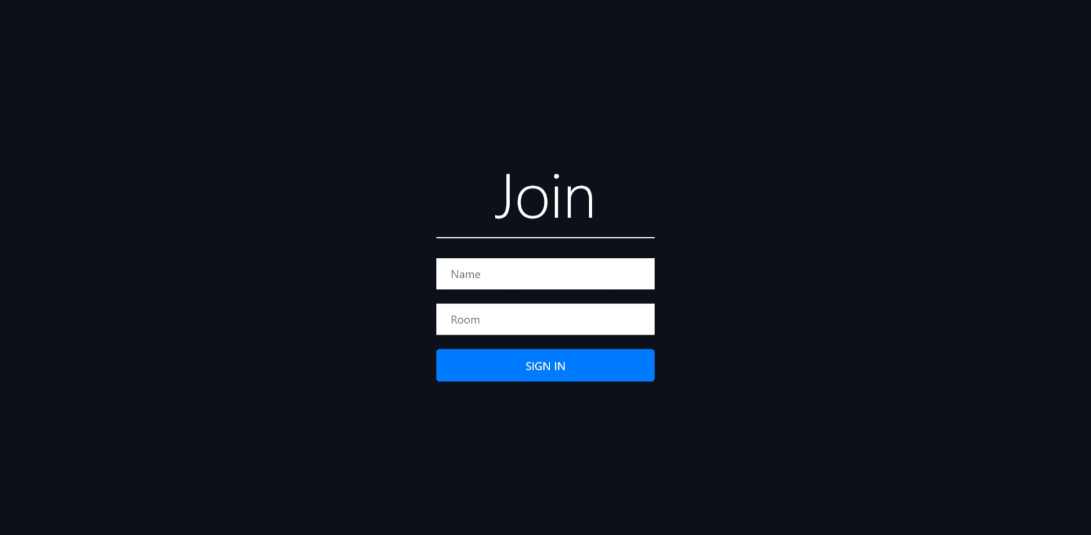

We have kept home page really simple so that people can quickly go down to business rather than worrying about login or signups.

It just needs name of the user and name of the room he wants to join. If the room with the same name exists, he will join that room otherwise new room with that name will be created.

After writing the name just click sign in and you will join the room.

1. **Chat Page design**

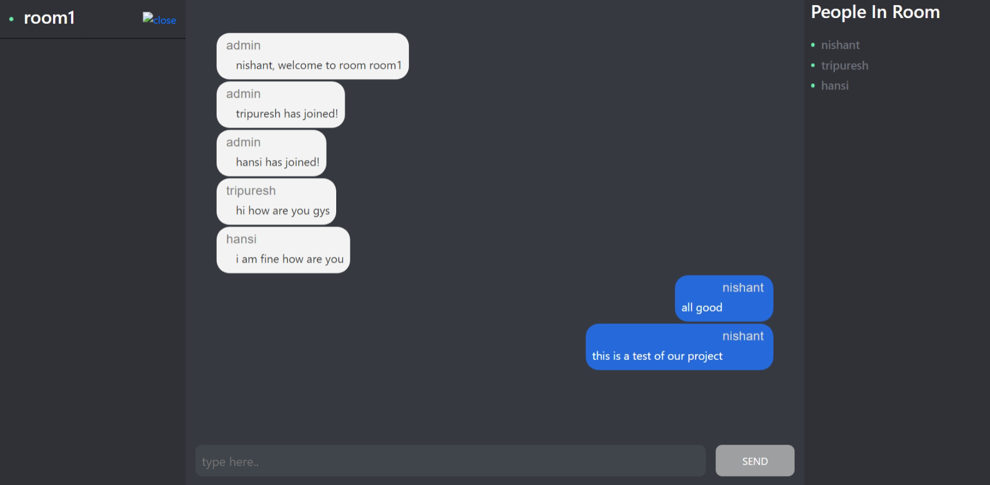

This is how chatting interface looks like. It has three parts

1. The left side shows you the name of the room you are currently in.
2. The middle part is where all the texting happens. You can write messages, send and view all the messages send by different users on in the room.
3. The right side shows all the current users in the room.

**FUTURE SCOPE**

* We will upgrade our application with option of voice chatting that will give it more functionality and convenience to the user.
* Adding ability to send photos and videos will also be our future agenda.

**References**

* [www.google.com](http://www.google.com)
* [www.reactjs.org](http://www.reactjs.org)
* [www.expressjs.com](http://www.expressjs.com)
* [www.nodejs.org](http://www.nodejs.org)
* [www.github.com](http://www.github.com)
* [www.geeksforgeeks.com](http://www.geeksforgeeks.com)
* [www.stackoverflow.com](http://www.stackoverflow.com)